Project Design Phase-II
Technology Stack (Architecture & Stack)
Date | 25 JUNE 2026
Team ID | SWTID20269563
Project Name | Smart Lender
Maximum Marks | 4 Marks

Technical Architecture:
The Deliverable shall include the architectural diagram as below and the information as per the table1 & table 2 Example: Order processing during pandemics for offline mode
Reference: https://developer.ibm.com/patterns/ai-powered-backend-system-for-order-processing-during-pandemics/
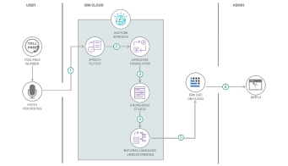
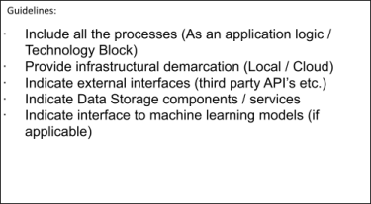
Table-1 : Components & Technologies:
S.No | Component | Description | Technology
1. | User Interface | Web interface for loan application prediction | HTML, CSS, JavaScript ,React.js

2. | Application Logic-1 | User registration ,login and authentication | Python(Flask)
3. | Application Logic-2 | Loan application processing and validation | Python , Pandas
4. | Application Logic-3 | AI-based loan approval prediction | Scikit-learn, Numpy
5. | Database | Store User ,application and prediction details | MySQL,
6. | Cloud Database | Cloud-Database Service on Cloud | Firebase/MySQL Cloud
7. | File Storage | Store uploaded documents and reports | Local File System/Firebase Storage
8. | External API-1 | Email notification service | SMTP/Email API
9. | External API-2 | OTP verification service | Twilio OTP API
10. | Machine Learning Model | Loan approval prediction Model | Random forest classifier
11. | Infrastructure (Server / Cloud) | Application deployment on server/cloud | Local Server /Render/Railway /AWS

Table-2: Application Characteristics:
S.No | Characteristics | Description | Technology
1. | Open-Source Frameworks | List the open-source frameworks used | Technology of Opensource framework
2. | Security Implementations | List all the security / access controls implemented, use of firewalls etc. | . SHA-256, HTTPS
3. | Scalable Architecture | Justify the scalability of architecture (3 – tier, Micro-services) | Three-Tier Architecture
4. | Availability | Justify the availability of application (e.g. use of load balancers, distributed servers etc.) | Cloud Hosting

S.No | Characteristics | Description | Technology
5. | Performance | Design consideration for the performance of the application (number of requests per sec, use of Cache, use of CDN’s) etc. | Pandas , NumPy,Optimized ML Model

References:
https://c4model.com/
https://developer.ibm.com/patterns/online-order-processing-system-during-pandemic/
https://www.ibm.com/cloud/architecture
https://aws.amazon.com/architecture
https://medium.com/the-internal-startup/how-to-draw-useful-technical-architecture-diagrams-2d20c9fda90d

